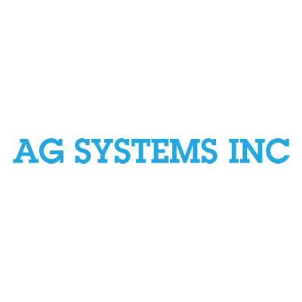

**NEWS RELEASE**

**FOR IMMEDIATE RELEASE**

**December 14th, 2023**

Contact: Jacey Cathey

Phone: (806) 781-5520

**Ag Systems Inc Employee Celebrates 40-Year Anniversary**

**GREAT BEND, KANSAS-** Ag Systems Inc. employee, Debora Fox-Johnson, celebrates 40 years with the business.

Ag Systems Inc., located in Larned, Kansas, is an irrigation and farm pivot insurance company. Johnson joined the team as their accountant in December of 1983, with her role continuously evolving.

“When I started, they were looking for someone to start their accounting on the computer, rather than everything by hand,” Johnson said. “I am now the office manager, insurance agent, and I also take care of center pivot financing.”

Established in 1974, Ag Systems Inc. specializes in agricultural services and irrigation systems. In the early 90’s, Johnson said they started selling pivot insurance alongside the sale of their irrigation systems. Johnson learned all of the procedures during this process, and by 2016, Johnson became a certified insurance agent.

Applying to work right before graduating with her associates, Johnson said when she hadn’t heard back, she went by to ask about the status of the job. Upon arrival, the manager at the time asked if she was ready to start working, and Johnson has been with them ever since.

Now nearing her 40-year mark, Johnson has seen a multitude of changes. From new ownership, to improved technologies, Johnson said she is very fortunate to still be with the company.

When asked what her favorite thing has been about working with Ag Systems over the years has been, Johnson’s said the relationships formed and connections made have made her job enjoyable.

“The people that I work with are like working with family,” Johnson said. “I have been truly blessed.”

After being with the company for so long, Johnson said she is excited to see what the future hold for her at Ag Systems Inc.

###

*Ag Systems Inc. provides reliable and experienced irrigation services in Great Bend, Kansas. Ag Systems partners with local feed yards and farmers to provide excellent service to their community. For more information, visit* [*https://www.agsystemsirrigation.com/*](https://www.agsystemsirrigation.com/)*.*